

# **LAB REPORT 4**

**KIRCHHOFF’S LAWS**

**Date of Experiment:**

**Date of Report:**

**Members:**



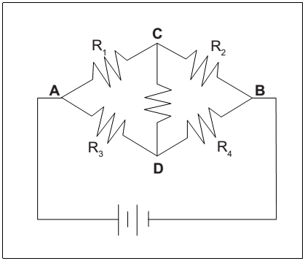



**Experimental Data:**

**Table 4.1**

|  |  |  |  |  |  |
| --- | --- | --- | --- | --- | --- |
| **Resistance (Ω)** | | **Voltage (V)** | | **Current (mA)** | |
| R1 | 99.8 | V1 | 0.523 | I1 | 4.30 |
| R2 | 146.5 | V2 | 1.010 | I2 | 4.46 |
| R3 | 219 | V3 | 0.369 | I3 | 2.43 |
| R4 | 464 | V4 | 0.431 | I4 | 2.29 |
| R5 | 556 | V5 | 0.329 | I5 | 0.128 |
| RTotal | 209 | VTotal | 1.474 | ITotal | 6.59 |

Using the schematic of the circuit, calculate the total resistance of the circuit. Record the value in the Table. 4.1. Based on the calculated resistance and the voltage across A and B, calculate the theoretical value of the current using Ohm’s Law.

Total current (theoretical) = $I_{\text{Total}}=\frac{1.474 V}{1485.3 Ω}=0.000992 A=0.992 mA$

Calculate the percent difference between the theoretical current and the measured current:



$$Percent difference=\frac{0.992mA−6.59mA}{6.59mA}∗100\%=84.95\%$$

Write down the Kirchhoff’s current law at the junctions A, B, C, and D into the table below. Use the experimental data above to find the net current flowing into (or out of) the junctions.

|  |  |  |  |  |  |
| --- | --- | --- | --- | --- | --- |
| **Junction** | **Kirchhoff’s current law** | **Current (mA, calculation)** | | **Current (mA, measure)** | |
| A | I0 = I1 + I3 | ITotal | 6.73 | ITotal | 6.59 |
| B | I0 = I2 + I4 | ITotal | 6.75 | ITotal | 6.59 |
| C | I1 = I2 + I5 | I1 | 4.64 | I1 | 4.3 |
| D | I3 = I5 + I4 | I3 | 2.47 | I3 | 2.43 |

Compare the currents calculated from Kirchhoff’s current law and those measured from experiment. Does the Kirchhoff’s current law hold true in the experiment?

Kirchhoff’s current law states that the sum of currents entering a junction is equal to the sum of currents leaving the junction. This is based on the principle of conservation of electric charge.

Let’s compare the calculated and measured currents for each junction:

Junction A: The calculated current is 6.73 mA, while the measured current is 6.59 mA.

Junction B: The calculated current is 6.75 mA, while the measured current is 6.59 mA.

Junction C: The calculated current is 4.64 mA, while the measured current is 4.3 mA.

Junction D: The calculated current is 2.47 mA, while the measured current is 2.43 mA.

The differences between the calculated and measured currents are small, which could be due to experimental errors or inaccuracies in measurement.

So, based on this data, it appears that Kirchhoff’s current law holds true in this experiment within a reasonable margin of error. However, it’s important to note that in real-world applications, other factors such as resistance changes due to temperature variations and wire resistance can affect these values.Write down the Kirchhoff’s voltage law for 4 different loops. For each loop, use the experimental data above to find the potential difference between a chosen component.

|  |  |  |  |  |  |
| --- | --- | --- | --- | --- | --- |
| **Loop** | **Kirchhoff’s voltage law** | **Voltage (V, calculation)** | | **Voltage (V, measure)** | |
| VR1R5R4 | +V – V1 – V5 – V4 | V1 | 0.714 | V1 | 0.523 |
| VR3R5R2 | +V – V3 + V5 – V2 | V3 | 0.135 | V3 | 0.085 |
| VR1R2 | +V – V1 – V2 | V1 | 0.526 | V1 | 0.523 |
| VR3R4 | +V – V3 – V4 | V2 | 1.105 | V2 | 1.010 |

Compare the voltages calculated and those measured from experiment. Does the Kirchhoff’s voltage law hold true in the experiment?

Kirchhoff’s voltage law states that the sum of the potential differences (voltages) around any closed loop or mesh in a network is always equal to zero. This is because a circuit loop is a closed conducting path, so no energy is lost.

Let’s compare the calculated and measured voltages for each loop:

Loop VR1R5R4: The calculated voltage is 0.714 V, while the measured voltage is 0.523 V.

Loop VR3R5R2: The calculated voltage is 0.135 V, while the measured voltage is 0.085 V.

Loop VR1R2: The calculated voltage is 0.526 V, while the measured voltage is 0.523 V.

Loop VR3R4: The calculated voltage is 1.105 V, while the measured voltage is 1.010 V.

The differences between the calculated and measured voltages are small, which could be due to experimental errors or inaccuracies in measurement.

So, based on this data, it appears that Kirchhoff’s voltage law holds true in this experiment within a reasonable margin of error. However, it’s important to note that in real-world applications, other factors such as resistance changes due to temperature variations and wire resistance can affect these values.

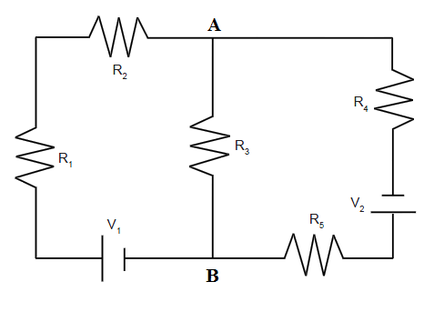



**Experimental Data:**



|  |  |  |  |  |  |
| --- | --- | --- | --- | --- | --- |
| **Resistance (Ω)** | | **Voltage (V)** | | **Current (mA)** | |
| R1 | 99.8 | V1 | 0.345 | I1 | 3.98 |
| R2 | 146.5 | V2 | 0.595 | I2 | 3.98 |
| R3 | 219 | V3 | 0.480 | I3 | 2.09 |
| R4 | 464 | V4 | 0.909 | I4 | 1.94 |
| R5 | 556 | V5 | 1.089 | I5 | 1.94 |
|  |  | V01 | 1.480 | I01 | 3.99 |
|  |  | V02 | 1.525 | I02 | 1.94 |

Write down the Kirchhoff’s current law at the junctions A and B into the table below. Use the experimental data above to find the net current flowing into (or out of) the junctions.

|  |  |  |  |  |  |
| --- | --- | --- | --- | --- | --- |
| **Junction** | **Kirchhoff’s current law** | **Current (mA, calculation)** | | **Current (mA, measure)** | |
| A | I2 = I3 + I4 | I2 | 4.03 | I2 | 3.98 |
| B | I5 + I3 = I1 | I5 | 1.89 | I5 | 1.94 |

Compare the currents calculated from Kirchhoff’s current law and those measured from experiment. Does the Kirchhoff’s current law hold true in the experiment?

Kirchhoff’s current law states that the sum of currents entering a junction is equal to the sum of currents leaving the junction. This is based on the principle of conservation of electric charge.

Let’s compare the calculated and measured currents for each junction:

Junction A: The calculated current is 4.03mA, while the measured current is 3.98mA.

Junction B: The calculated current is 1.89mA, while the measured current is 1.94mA.

The differences between the calculated and measured currents are small, which could be due to experimental errors or inaccuracies in measurement.

So, based on this data, it appears that Kirchhoff’s current law holds true in this experiment within a reasonable margin of error. However, it’s important to note that in real-world applications, other factors such as resistance changes due to temperature variations and wire resistance can affect these values.Write down the Kirchhoff’s voltage law for 2 different loops. For each loop, use the experimental data above to find the potential difference between a chosen component.

Write down the Kirchhoff’s voltage law for 3 different loops. For each loop, use the experimental data above to find the potential difference between a chosen component.

|  |  |  |  |  |  |
| --- | --- | --- | --- | --- | --- |
| **Loop** | **Kirchhoff’s voltage law** | **Voltage (V, calculation)** | | **Voltage (V, measure)** | |
| V1R1R2R3 | +V01 - V1 - V2 - V3 | V1 | 0.405 | V1 | 0.345 |
| V2R5R3R4 | +V02 - V5 +V3 - V4 | V3 | 0.473 | V3 | 0.480 |
| V1R1R2R4V2R5 | +V01 - V1 - V2 - V4 + V02 - V5 | V4 | 0.976 | V4 | 0.909 |

Compare the voltages calculated and those measured from experiment. Does the Kirchhoff’s voltage law hold true in the experiment?

Yes, due to the calculation and experiment values, the Kirchohoff’s voltage law hold true in the experiment. In fact, it is true that the experiment values only approximate the meansured values, but the difference are not significant so the Kirchohoff’s voltage law still hold true.